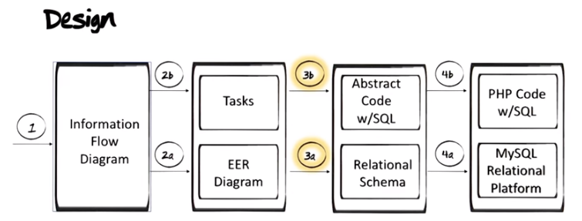
別忘了上圖中的四個分別為:

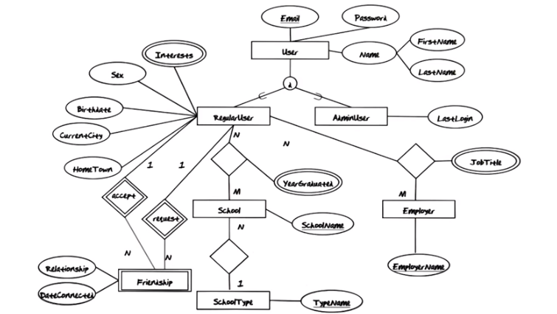

The above figure: Here's the extended entity-relationship diagram we ended up with. …. So our job now is to take this extended entity-relationship diagram and translate it into a relational database. We will do that a little step at a time. 注意上圖的之前出現時, accept和Friendship之間是粗線, request和Friendship之間也是粗線, 這裡是劃錯了, 日他大爺.

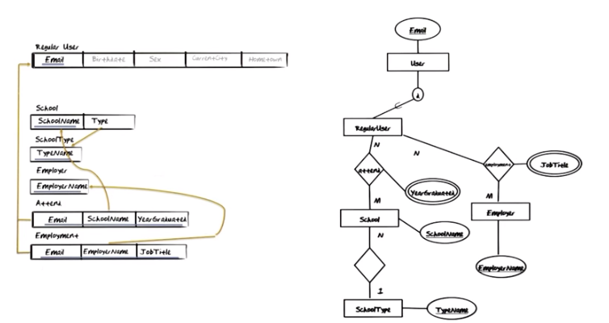
The above figure: School這個表中的Type: the Type you see here is basically a foreign key pointing to the primary key of SchoolType.

The Attend relationship type is a many-to-many relationship type as you can see. In order to map a many-to-many relationship types we need the identifying property type of each one of the participating entity types. So we need Email to identify RegularUser and we need SchoolName to identify the School. What is a little bit different about this mapping is that for each one of these instances, there is a YearGraudated associated with it. One reason for that could be that you might attend, for example, Georgia Tech twice, once for your bachelors and once for your masters. In each one of those, there will of course be a unique YearGraduated (這就是EER圖中relationship帶property(應該都是multi-valued property)時的意思, 己copy到我的note 3. Extended-Entity Relationship Model中). 注意Attend的identifier是Email-SchoolName-YearGraduated一起組成的.

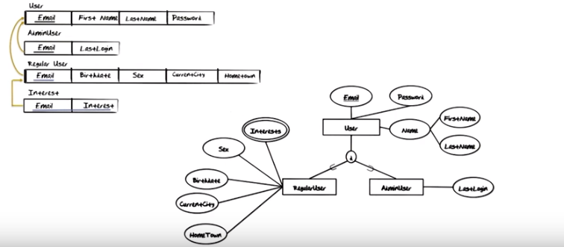

The above figure: 注意原圖中User和d之間是粗線. 弄d時, there were couple of options in the mapping. We have chosen the option where we create a relation for each one of the entity types.

Good: 對於RegularUser and AdminUser, both of those will inherit Email, Passowrd, FirstName, and LastName. However, in the mapping of each one of these entity types, the only one of these that will appear is the identitying property type Email, which would become the primary key in the AdminUser relation and in the RegularUser relation. 當然RegularUser和AdminUser自己的extra的property還是要加上.

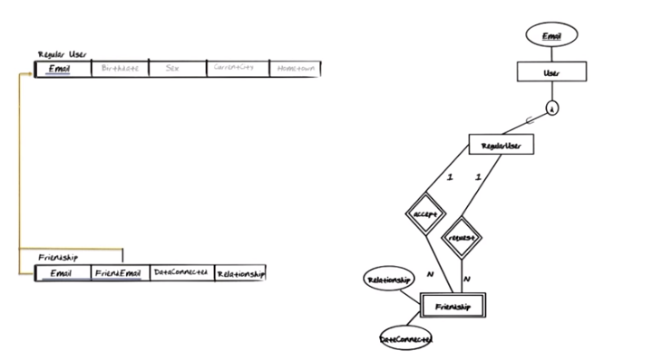
上圖複雜的地方在於RegularUser和Friendship之間有兩個identification relationship. 所以對應的Friendship表中, it will have email twice. 其中的Email即email of the one making the request(即對應request這個relationship), FriendEmail即email of the friend that the request is being made to(即對accept這個relationship).

Notice that there are two 1-to-many relationships into friendship. And typically when we have a many-to-many relationship type, that can actually be modeled by two 1-to-many relationships into the same entity type. When that's the case, then the combination(即Email和FriendEmail) is a key. That corresponds very much all the cases we've seen of many-to-many relationship type where you take a key from each end of the relationship.

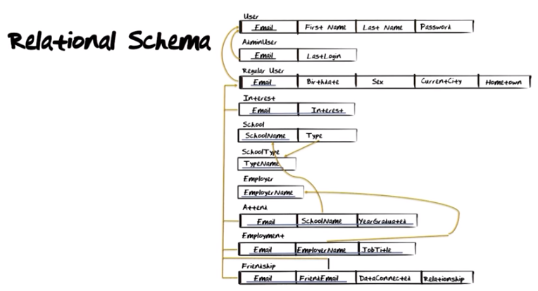



The above figure: Before we go any further, we need a small detour to study an additional database tool or technique.

